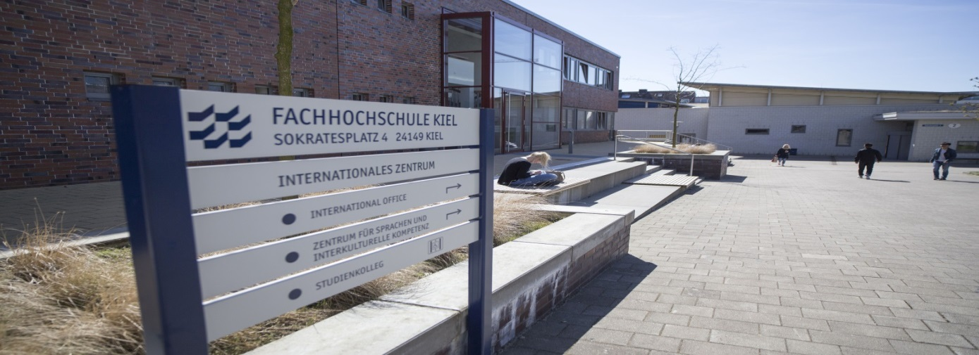
On offer at CLIS are a range of great language and intercultural courses for UAS Kiel students – both home and study abroad. These courses are free of charge and are credit point worthy: for study abroad students, courses for credit must be arranged with the home university. All courses are taught by experienced mother-tongue language teachers.
What you can study at CLIS (general language skills):

English (B1 – C2)
French (A1 – C1)
Spanish (A1 – C1)
Chinese (A1)
Danish (A1 –A2)
Polish (A1)
Russian (A1 – A2)
Swedish (A1 – A2)
German as a Foreign Language (A1 – C1)
Turkish (A1)

In English, French, Spanish and German, it is also possible to study business language and intercultural studies orientated courses (from B1 to C1/C2 levels), as well as to gain training for external internationally recognised language certificates.
Furthermore, together with Kiel UAS’ International Office, study abroad students are encouraged to participate in the Study Buddy programme, where incoming students are teamed up with home students to foster language and intercultural learning, friendship and academic insight.

Every semester, UAS Kiel is also home to the Interdisciplinary Weeks – a two-week lecture-free period when students are able to choose from hundreds of workshops, seminars, projects, lectures and excursions that suit personal interest or academic need.
Some previous CLIS offers include:
Build Your Own Blog
Storytelling through comics
Cooking in French
Creating Apps for your Android phone
Programming with Lego Mindstorm

Get down with Salsa and Samba
Excursion to a working Viking village
Relax and find your centre with Qi-Gong
Beginner’s Japanese
What the heck are the US mid-terms?
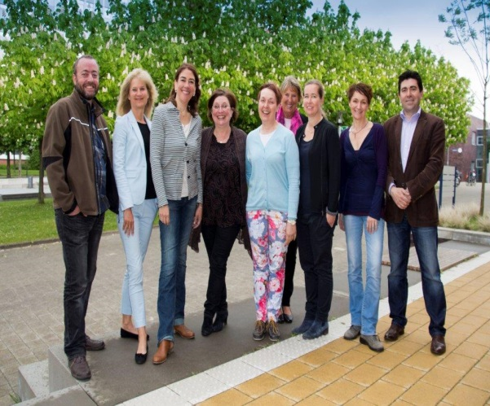
Your CLIS Team
By participating in CLIS courses, what you will certainly not be is bored. Our teaching style ethos is for real, natural and interactive learning…with a little fun thrown in along the way.
Come and join us!
Contact: stephen.walsh@fh-kiel.de

